On an initially alongshore uniform beach, rip channels are thought to develop as a response to small initial disturbances that grow.

*Underlying such a hypothesis is the concept of:*

|  |  |  |
| --- | --- | --- |
|  |  | negative feedback |
|  |  | forced behaviour |
|  |  | positive feedback |

*An elongated trough that runs (almost) parallel to the shore is called:*

|  |  |  |
| --- | --- | --- |
|  |  | something else |
|  |  | a cusp |
|  |  | a berm |
|  |  | a runnel |
|  |  | a ridge |

Over the period of years alongshore bars tend to show a net cross-shore movement.

*The bars:*

|  |  |  |
| --- | --- | --- |
|  |  | are generated at the shoreline and then move offshore: TRUE |
|  |  | are generated at the shoreline and then move offshore: FALSE |
|  |  | have a maximum amplitude at the offshore end of the lower shoreface: TRUE |
|  |  | have a maximum amplitude at the offshore end of the lower shoreface: FALSE |

*The concept of dynamic profile equilibrium refers to the fact that:*

|  |  |  |
| --- | --- | --- |
|  |  | the yearly-averaged position of a coastal profile may slowly shift in time due to long-term forcing such as sea-level rise. |
|  |  | the coastal profile shows dynamic variation at the scale of the varying wave forcing around a constant time-mean position. |
|  |  | the equilibrium position of the coastal profile is unstable even for constant forcing. |
|  |  | none of the other answers |

According to Bruun, relative sea-level rise leads to a coastline retreat equal to:

Retreat = *RLSR(L/d)*

where *RSLR*is the rise of relative sea level above MSL.

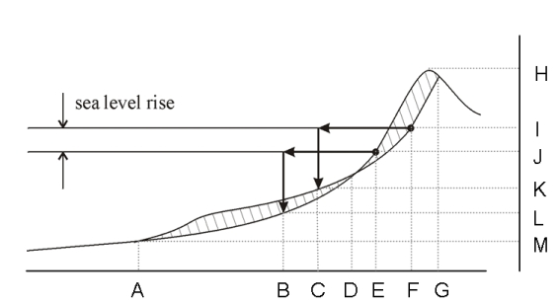

*Indicate, based on the points indicated in the figure, which distances correspond to* L*:*

Lis the distance between points 

*Note: Type in capitals (e.g. CD).*

A linearly sloping beach profile is built in a laboratory flume and subsequently subjected to regular waves with a certain height and period.

The bed profile is measured at fixed time-intervals.

From these profile measurements, sediment transport rates are determined.

The test is carried on until the transport rates are very small.

Then, the test is continued with waves with a twice larger wave height.

*What can be concluded about the transport rates in this second part of the test?*

|  |  |  |
| --- | --- | --- |
|  |  | The transport rates are onshore directed: TRUE |
|  |  | The transport rates are onshore directed: FALSE |
|  |  | The transport rates increase linearly in time: TRUE |
|  |  | The transport rates increase linearly in time: FALSE |

*For a depositional coastal environment, parallel or nearly parallel depth-contours are generally found:*

|  |  |  |
| --- | --- | --- |
|  |  | In the littoral zone only |
|  |  | On the entire shoreface |
|  |  | In deep water |
|  |  | None of the other answers |

*A dissipative beach would typically have the following characteristics:*

|  |  |  |
| --- | --- | --- |
|  |  | Relatively coarse material |
|  |  | A narrow surf zone |
|  |  | A steep berm |
|  |  | High morphodynamic variability |
|  |  | Spilling breakers |

Consider a coastal profile with the onshore direction taken as positive.

Assume that the horizontal velocity *u*(*t*) close to the bed is the sum of a time-averaged component *ū*, an oscillatory component *ulo*(*t*) at the wave group scale and a short-wave oscillatory component *uhi*(*t*), hence *u*(*t*) = *ū* + *ulo* + *uhi*.

Herewith, the third odd velocity moment can be decomposed as (time-averaging indicated by brackets):

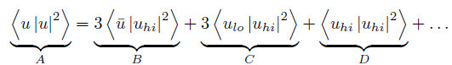

The magnitude and sign of each of these four terms depends on the location on the shoreface.  
  
*Select the term(s) in the above equation that is(are) never negative on the shoreface.*

|  |  |  |
| --- | --- | --- |
|  |  | A |
|  |  | B |
|  |  | C |
|  |  | D |

Consider a coastal profile with the onshore direction taken as positive.

Assume that the horizontal velocity *u*(*t*) close to the bed is the sum of an oscillatory component *ulo*(*t*) at the wave group scale and a short-wave oscillatory component *uhi*(*t*), hence *u*(*t*) = *ulo* + *uhi*.

Herewith, the third odd velocity moment can be decomposed as (time-averaging indicated by brackets):

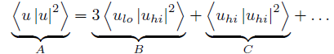

Term B changes sign from negative outside the surf zone to positive near the shore.

*At the location of changing sign, the maximum onshore long wave velocity occurs simultaneously with:*

|  |  |  |
| --- | --- | --- |
|  |  | a wave in the group with an average height |
|  |  | the largest short wave in the group |
|  |  | the smallest short wave in the group |

*A reset event:*

|  |  |  |
| --- | --- | --- |
|  |  | Wipes out the 3D structure of the morphology: TRUE |
|  |  | Wipes out the 3D structure of the morphology: FALSE |
|  |  | Is a process that may take weeks to months: TRUE |
|  |  | Is a process that may take weeks to months: FALSE |

*The upper shoreface:*

|  |  |  |
| --- | --- | --- |
|  |  | Consists of the shoaling zone and surf zone: TRUE |
|  |  | Consists of the shoaling zone and surf zone: FALSE |
|  |  | Is also referred to as littoral zone: TRUE |
|  |  | Is also referred to as littoral zone: FALSE |
|  |  | Is morphologically inactive: TRUE |
|  |  | Is morphologically inactive: FALSE |

Which of the following mechanisms are an important contributor to onshore sediment transport?

|  |  |  |
| --- | --- | --- |
|  |  | gravity under the influence of the average bed slope |
|  |  | Stokes' drift |
|  |  | completely bound long waves |
|  |  | long waves positively correlated to the slowly varying wave amplitude in a group |
|  |  | wave boundary layer streaming |